Ecorys UK
Environmental Policy 2021-2025

Contents
Introduction 6
1.0 Ecorys UK environmental policy statement 7
2.0 Ecorys UK’s carbon footprint 7
3.0 Ecorys UK Climate Neutral Task Force 8
4.0 Environmental policy objectives 9
5.0 ISO 14001 Environmental Management System 10
6.0 Climate Action Plan 2022/2023 11

Ecorys UK Environmental Policy 2021-2025

DOCUMENT REF | Ecorys UK environmental policy
VERSION | 2
DATED | 21 July 2022
DOCUMENT AUTHOR | Adriana Rodriguez
DOCUMENT OWNER | Adriana Rodriguez

Revision history
VERSION | DATE | REVISION AUTHOR | SUMMARY OF CHANGES
V1 | 14/06/2021 | Adriana Rodriguez  Management Board | Added total carbon footprint  Added ambition to obtain ISO 14001 certification
V2 | 21/07/2022 | Adriana Rodriguez | Changed CO2 emission calculations, action plan and CNTF organigram

Distribution
NAME | TITLE
All members of the Board | Ecorys UK Management Board

Approval
NAME | POSITION | SIGNATURE | DATE
All Management Board members | Management Board members | Nicola Smith | 31/07/2022

Introduction
Ecorys UK is committed to reducing the negative environmental impact of its business activities. This policy explains our commitments to become a greener company; including how we are planning to reduce our carbon footprint and work towards environmentally friendly business operations.
This policy document includes the following sections:
- Ecorys UK environmental policy statement. This statement sums up our environmental commitment. We will use it to promote our environmental ambitions inside and outside of Ecorys UK.
- Ecorys UK’s carbon footprint. This section provides an overview of our CO² emissions produced in 2019 and 2020 to help us understand our baseline position and determine our objectives and priorities for the next few years.
- Ecorys UK Climate Neutral Task Force. This section describes the role and responsibilities of the Ecorys UK Climate Neutral Task Force.
- Environmental policy objectives. This section describes our shorter-term objectives to achieve our overarching and long-term environmental goal.
- ISO 14001 Environmental Management System (EMS). This section explains how we have set up a comprehensive EMS and obtained the ISO 14001 certification.
- Overview of Ecorys UK’s Climate Action Plan 2022/2023. This section provides a list of actions that we aim to implement to contribute to our short-term objectives and overarching environmental goal.

Ecorys UK environmental policy statement
Ecorys UK is committed to the protection of the environment. Our ambition is to become a carbon-neutral company by 2030. Ecorys UK is committed to reducing its carbon footprint by:​
- ​Changing and reducing travel habits towards achieving carbon neutrality.
- Monitoring, measuring, and analysing progress towards carbon neutrality​.
- Raising awareness and promoting environmentally friendly practices among stakeholders​.
- Reducing waste in general and increasing the amount of our waste that is recycled​.
- Working with suppliers and partners to establish environmentally friendly practices. ​
- Offsetting CO2 emissions, where necessary.
- Complying with all applicable environmental legislation and sustainability commitments.

Ecorys UK’s carbon footprint
In 2019, Ecorys UK produced an estimated 704 CO² tonnes. Around 70% of these emissions came from international travel. Many of Ecorys’ international and European research projects required staff to travel internationally for client meetings, data collection activities, events etc. Thus, most of our emissions came from these project-related activities. Ecorys UK produced substantially higher levels of carbon dioxide (CO²) than the rough estimate average for medium-size businesses in the UK in 2019. This rough estimate is 100 to 200 tonnes of CO² per year. However, this rough estimate does not include emissions produced by international travel so full comparability is limited. Without international travel, Ecorys UK emissions produce 240 CO² tonnes which is slightly more in line with the average.
Figure 1: Ecorys UK CO² emissions (%, 2019)

In 2020, Ecorys UK produced an estimate of 311 CO² tonnes. This figure represents a 55% decrease in CO² emissions compared to the previous year. Due to COVID-19, international travel in 2020 was very limited and many project activities took place online. Without international travel, Ecorys UK produced 190 tonnes of CO² emissions in 2020, of which 26% were linked to commuting,16% to the electricity consumption in our London office and 10% from electricity and heating usage from home working.

Ecorys UK Climate Neutral Task Force
A Climate Neutral Task Force (the ISO 14001 committee) was set up in April 2021. This task force aims to ensure that Ecorys UK meets its long-term objective of becoming a carbon-neutral company by 2030 by working on the actions listed in Section 5. Additionally, the task force aims to prepare Ecorys UK for the ISO 14001 environmental management certification.
The team is formed of eleven members. Nicki Smith (Board Sponsor), Adriana Rodriguez (Project Manager), Lucy Holloway-Bone (Compliance Officer) and Robert Holdcroft (ISO Manager) are supported by seven climate-neutral champions from across the UK business. The board sponsor represents the Ecorys UK senior management team and ensures alignment of environmental objectives and actions with Ecorys UK business strategies and other policies. The project manager organises the efforts and activities to maintain the ISO certification and Ecorys UK environmental ambitions. The compliance officer and ISO manager ensure that Ecorys UK’s efforts to obtain the ISO 14001 certification are coordinated with other existing ISO certifications and prepare internal audits to prepare for the ISO external audits. The five champions engage with staff and raise awareness of the objectives and actions to reach our objectives.
Figure 2: Ecorys UK Climate Neutral Task Force
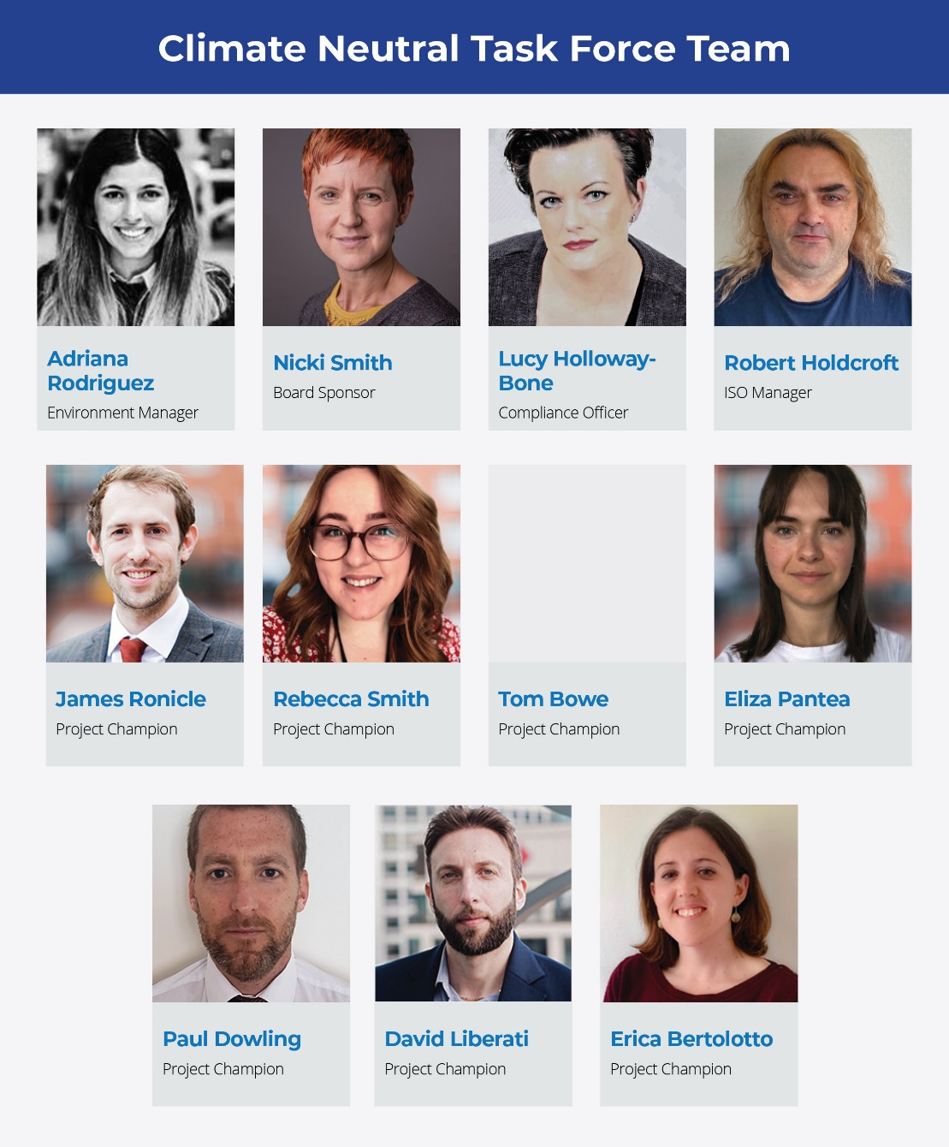

Environmental policy objectives
Ecorys UK aims to become a carbon neutral company by 2030. To achieve this goal, we will:
- Measure our carbon footprint. Ecorys UK’s environmental team will measure Ecorys UK’s carbon footprint based on all aspects of the business, determine annual CO² emission levels and targets, and develop monitoring tools and practices to measure CO² emissions per business activity. The previous section provides an estimate of Ecorys UK emissions in 2019 and 2020.
- Reduce CO² emissions of in-house operations. Several actions will be implemented to reduce in-house emissions including changing to greener suppliers across our supply chain and promoting environmental practices to change stakeholders’ behaviour and practices.
- Offset CO² emissions that are not possible to eliminate completely. Ecorys UK will find suitable local projects to offset CO² emissions that cannot be fully reduced, for example: CO² emissions generated by international travel.
To achieve carbon neutrality, Ecorys UK needs to reduce its yearly carbon footprint by working towards the following six short-term objectives:
- Maintain the minimum amount of travel by, for example: promoting the use of virtual tools for client meetings, planning for longer fieldwork or groups of meetings/interviews on the same trip and organising fieldwork for several projects in the same location at the same time.
- Monitor, measure and analyse Ecorys’ carbon footprint. It is important to continue building our internal capacity and tools to monitor and measure our impact on the environment and analyse how we can work towards carbon neutrality. Having good monitoring and measurement practices and tools in place will enable Ecorys UK to draw from lessons learnt each year and improve our environmental performance.
- Ensure and promote environmental responsibility through our work. ​Ecorys UK will comply with legal environmental requirements, strengthen tendering practices (e.g., continuously improving upon our social value statement and providing tools to calculate project CO² emissions at proposal and project delivery stage) and ensure suppliers and partners have established environmental commitments.
- Align Ecorys’ policies and strategies with Ecorys’ environmental policy objectives and actions. ​​Ecorys UK aims to align all policies and strategies with its environmental objectives. Ecorys’ environmental team will review and contribute to the development of relevant policies and strategies such our travel and hybrid-working policies.
- Find opportunities to reduce and offset CO² emissions.​There is a need to offset some of the CO² emissions that cannot be reduced completely. We will work closely with Ecorys NL, which is already a carbon-neutral company, to identify the best opportunities to reduce and offset our CO² emissions.
- Raise awareness and promote environmentally friendly practices (incl. environmental policy) among stakeholders. Ecorys aims to inform and make all employees aware of our environmental ambitions. We will work on raising awareness and communication activities to promote Ecorys UK’s long-term goal of becoming a carbon-neutral company by 2030 while also promoting changes in employees’ and stakeholders’ behaviour towards more sustainable and green business practices and activities.

ISO 14001 Environmental Management System
To ensure Ecorys UK achieves its long-term environmental objective in an effective manner, we have set up a comprehensive environmental management system (this environmental policy is part of the EMS system). In December 2021, Ecorys UK obtained the ISO14001 certification.
There are several reasons why we got ISO14001 certified:
1. Control suppliers – ISO 14001 prevents our good work being undone by suppliers with poor environmental performance.
2. Win more business – the certification is increasingly a requirement when bidding to win work with the public sector.
3. Legal compliance – comply with regulations and avoid fines and sanctions against our business.
4. Cost savings – through better energy management, efficient use of resources such as water and reduced waste.

Climate Action Plan 2022/2023
We have developed an action plan to work towards the reduction of our CO² emissions and maintain the ISO 14001 certification. Below, we have listed some actions that we will work on this year:
- Investigate private pension providers that support climate change ambitions and take climate change into account as a risk when investing and prepare info session on sustainable pension funds.
- Run promotional activities to encourage staff to cycle and/or travel by public transport.
- Test and roll-out our project carbon calculator.
- Organise communication activities to inform Ecorys staff and externals about our ISO14001 certification.
- Select a carbon offsetting provider and start offsetting emissions we cannot fully reduce.
- Participate in volunteering activities related to environment preservation (e.g., planting trees) and promote these activities to our staff.
- Prepare awareness-raising activities to promote positive messages about helping the environment and reducing our impact (e.g., quiz, factsheets, videos, presentations, create a contest or ongoing ‘green’ challenges with staff).
- Ask suppliers and partners for their environmental policy/responsibility statement and increasingly work with green suppliers.
- Bid for projects in which Ecorys can contribute to environmental policies (e.g., research, communication or programme-management projects on environmental topics).
- Quarterly environmental taskforce meetings to update on progress.

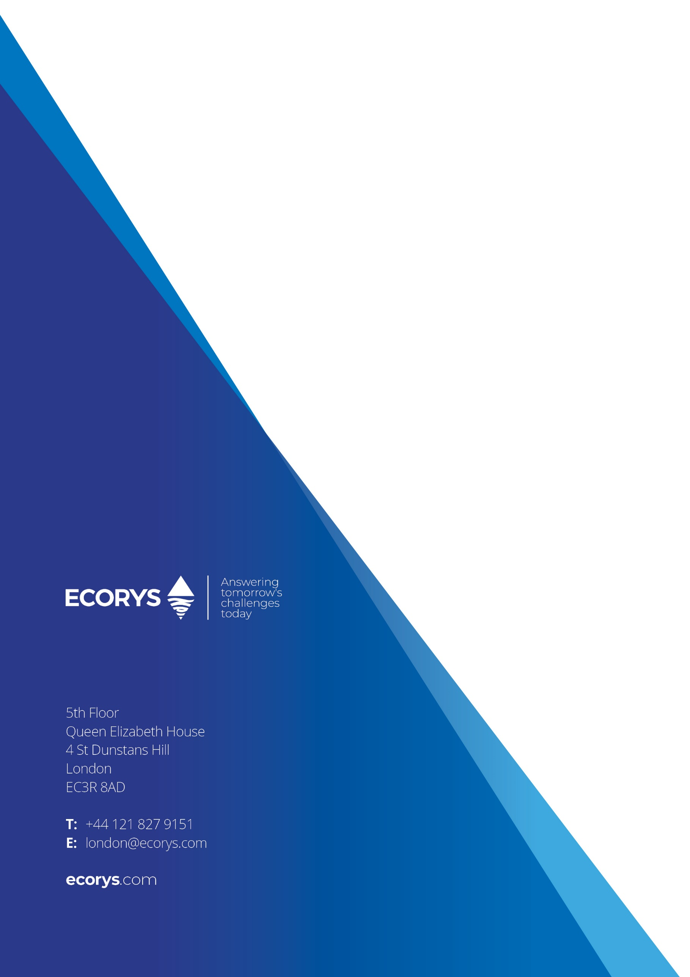

To calculate the total carbon footprint of Ecorys UK for 2019 and 2020 we use some estimations for our water and gas usage (e.g., medium/large companies in the UK use 15,000 KWh on gas) as well as daily commute by car and public transport.
Water and gas consumption was estimated using data provided Leeds office. CO2 emissions produced by daily commute were estimated using the following sources: https://www.eea.europa.eu/highlights/average-co2-emissions-from-new and https://www.carbonindependent.org/20.html#:~:text=the%20average%20CO2%20emission%20for,i.e.%200.07%20tonnes%20per%20person%5D
https://www.makeitwild.co.uk/carbon-mitigation-for-businesses-with-make-it-wild#:~:text=As%20a%20rough%20guide%2C%20the,tonnes%20for%20a%20large%20business
Water and gas consumption was estimated using data provided Leeds office. CO2 emissions produced by daily commute were estimated using the following sources: https://www.eea.europa.eu/highlights/average-co2-emissions-from-new and https://www.carbonindependent.org/20.html#:~:text=the%20average%20CO2%20emission%20for,i.e.%200.07%20tonnes%20per%20person%5D
Energy provider: MA Energy. Only uses 8% of renewable sources to produce electricity. Electricity providers in Leeds and Birmingham office produce energy using renewable sources, thus there is not CO2 emitted from the consumption of electricity in these offices.
Home working emissions were not part of 2019 baseline calculations. Home working emissions have been included in our CO2 emission monitoring tool from 2020.

